**Business Problem:**

Car accidents lead to fatalities and economic losses. Thus, preventing loss of life and property is a topic of concern.

The Seattle Department of Transportation kept the detailed records of car accidents. The big question asked is whether the government can deploy a system that can alert drivers, health system, and police to remind them to practice caution and alertness in case of an incident. To development this model, several key questions we may ask:

* Is the car accident severity associated with objective factors such as weather condition, light condition, certain days or weekend, etc?
* Is the car accident severity associated with transportation infrastructure such as pedestrian side way, road type, cross street setting?
* Is the car accident severity associated with subjective factors related to driver, such as driver’s inattention, influence by drugs or alcohol?
* Is the car accident severity happened in certain location?

If we could build up such model to predict the possibility of car accident and how severe it could be, given the key factors related to car accidents. The government can alert people to drive more carefully or even change their travel if possible based on the objective and/or subjective factors involved. Also, the government can take proactive actions to improve the observed the key factors and further reduce the number of car accidents.

**Understand the Data:**

Seattle Department of Transportation collects all the collision data and records by traffic records. Data includes all the types of collisions like angles, sideswipe, parked cars. These collisions will be displayed at the intersection or mid-block of a segment. The timeframe of data is from 2004 to the present. The data is located in: <https://s3.us.cloud-object-storage.appdomain.cloud/cf-courses-data/CognitiveClass/DP0701EN/version-2/Data-Collisions.csv>

At a glance of the data:

The total data size is (194673,38). And each attribute type is as blow:



From the total 38 attributes:

SEVERITYCODE will be the dependent variable, it’s categorical data with value:

0: Little to no Probability (Clear Conditions)

1: Very Low Probability — Chance or Property Damage

2: Low Probability — Chance of Injury

2b: Mild Probability — Chance of Serious Injury

3: High Probability — Chance of Fatality Following is a table of all the attributes along with their data types, variable length and a description for understanding.

From source data, it’s distributed as:

All the total data 194673 are all categorized into 1 or 2 severity categories:



As SEVERITYCODE is the predictive variable, and compensate the SEVERITYCODE data will skew the data and model will be inaccuracy. Thus, the model will go with Binary Logistic Regression and/or Decision Tree

Other attribute will be potential Independent variable (also refer to ‘features’ later):

* X, Y is the Longitude and Latitude factor, it will be used for map plotting
* OBJECTID, INCKEY, COLDETKEY, INTKEY and REPORTNO. are the unique identifiers, won't help in the model and will be dropped from data set
* EXCEPTRSNCODE, EXCEPTRSNDESC, STATUS won’t be contributing to our dataset. Will be dropped.
* LOCATION data maybe help us in populating the maps and getting the count in a particular area but the X latitudes and Y longitudes and already in place to serve that purpose.
* SEVERITYCODE.1 and SEVERITYDESC are duplicated with SEVERITYCODE and won't take into the model.
* INCDATE — Incident Date and INCDTTM — Incident Timestamp, INCDATE will be maintained and transfer to certain 'Day of Week' or 'WeekEnd' to judge whether the car accidents related to certain day of week or weekend. The timestamp column doesn’t have consistent values. in this exercise, will not take it as critical features (further study will do regarding question: whether car accident related to certain time of day).
* SDOT_COLCODE and SDOT_COLDESC are redundant, ST_COLCODE, ST_COLDESC, are the repeated features and information only, which shouldn’t be considered in further analysis
* SDOT_COLNUM doesn't have linearrelationship with SEVERITYCODE, drop from the dataset
* COLLISIONTYPE has some missing values. Theoretically, those can be filled by mapping the SDOT_COLDESC values, SDOT_COLDESC involves the collision description. However, by examining the data and found the inconsistent usage of SDOT_COLDESC. And consider the total missing data is 4904 vs total 194673. The none filled value will be dropped
* Features like JUNCTIONTYPE, WEATHER, ROADCOND, LIGHTCOND contain null values, it would be mapped to 'unknown'
* Features like INATTENTIONIND, UNDERINFL, SPEEDING, PEDROWNOTGRNT, HITPARKEDCAR are variables with binary values and has values input for only one class. Thus, we can induce the either value to account for all the blank cells. However, considering the # of UNDERINFL is small, will map its Y value to "INATTENTIONIND" and drop it (with normal philosophy assumption the Under DRUG/ALCOHOL will influence the "INATTENTIONIND" to Yes)
* Features like SEGLANEKEY, CROSSWALKKEY, PEDCOUNT, VEHCOUNT, PEDCYLCOUNT should be examined and normalized, if they aren’t correlated to the target variable then they should be excluded, it can be conceived as noise.

**Analytical Techniques**

For this project, Github repository (<https://github.com/songttony/Coursera_Capstone>) is used to commit changes and updation of the code.

[IBM Cloud Jupyter Notebook](https://dataplatform.cloud.ibm.com/analytics/notebooks/v2/9f84ee68-cf15-4ee3-af2f-3178ea81c15c?projectid=9fe9f2aa-a45d-467d-9681-63c650e2b1b9&context=cpdaas) is used for coding and to preprocess data and build Machine Learning models. Python packages included for coding are including:

* Pandas, NumPy and Sklearn for data processing, Standard scaler for data normaliztion, etc..
* Scipy for statistical analysis such as Pearson correlation analysis, Chi-Square analysis, etc.
* Matplotlib, pyplot, seaborn for visulizations, Classification reports as an evaluation metric.

In this car accident severity modeling, the input vectors are the features of the accident, such as driver behavior, road infrastructure and environment characteristics such as weather, light, etc, while the output vector is the corresponding class of accident severity. And the model used will be Logistic Regression/Tree Decision

**Methodologies - Exploratory Data Analysis**

**Data Preparation:**

Before exploring the data, notice that there are several issues in the original dataset, such as missing data, data type inconsistent, no useful data, etc.

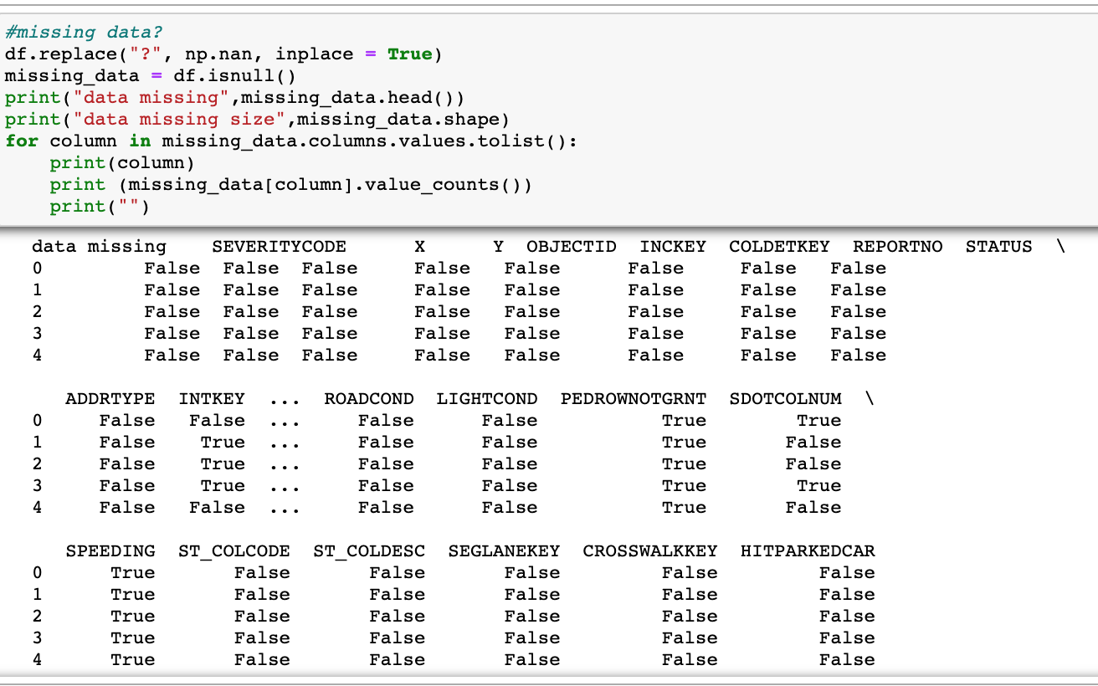

With that in mind, first, filling the missing data, convert the date type and drop the NaN data value.

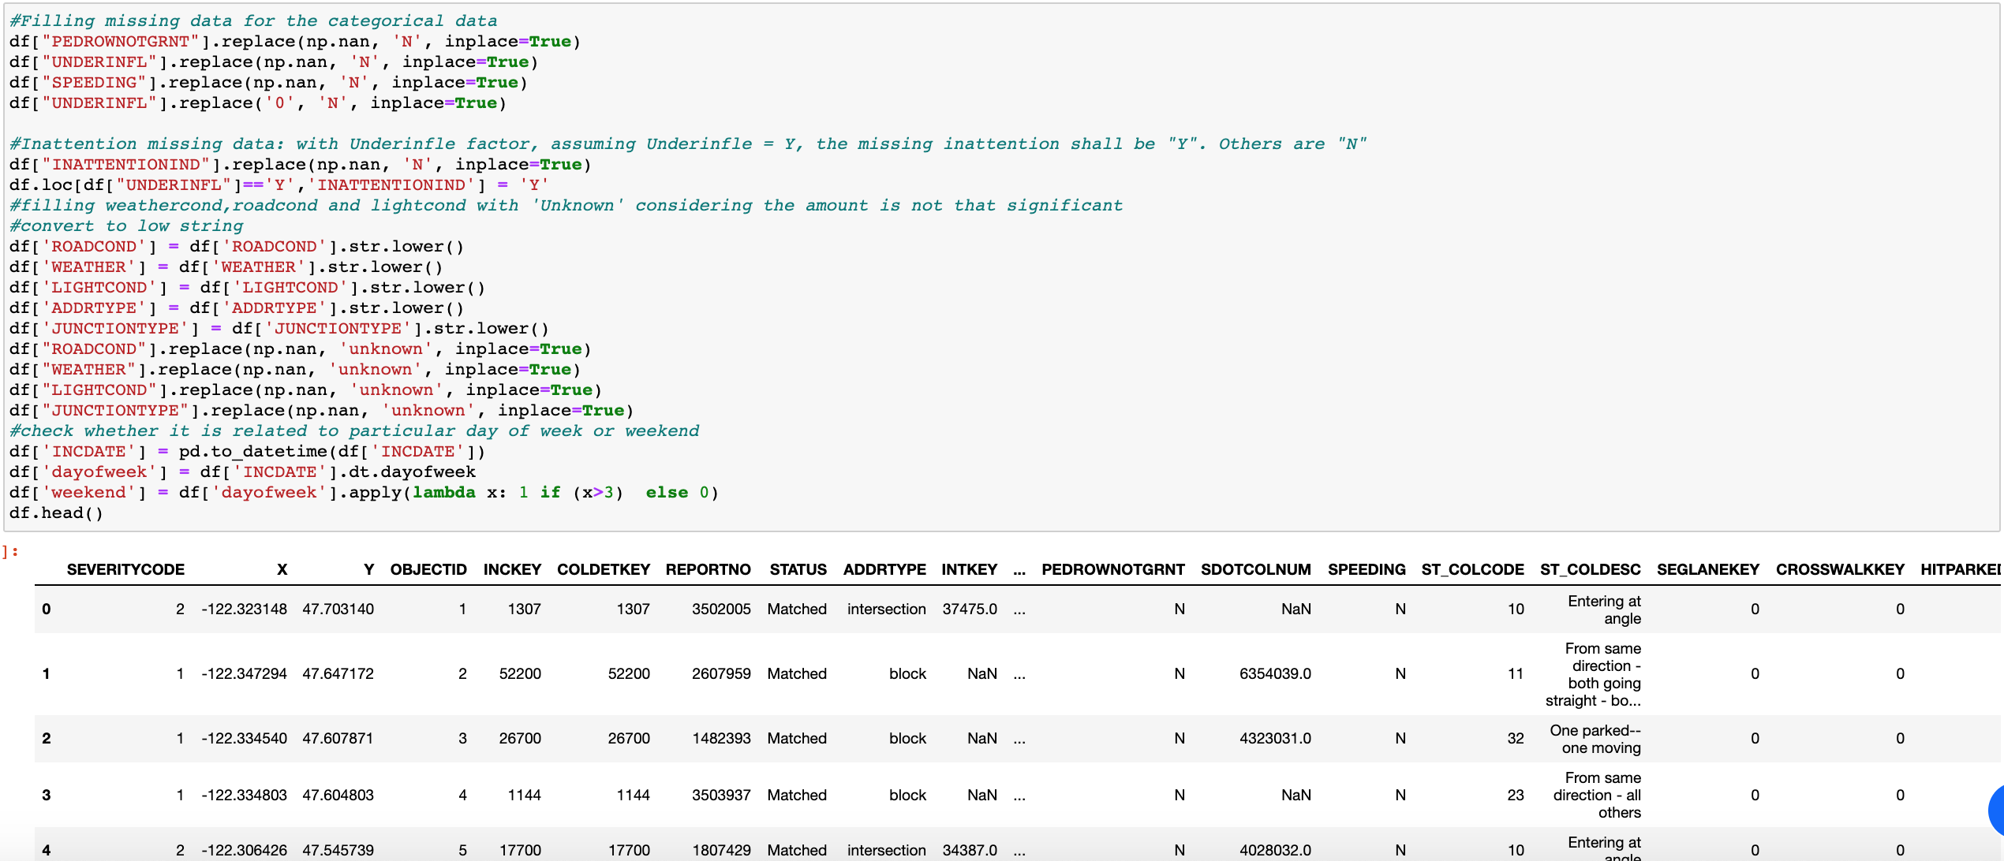

After this is done, the missing data value is compared as below two pictures:

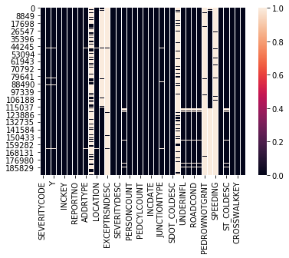 Before VS. After 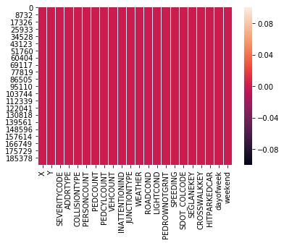

And then performed the statistical analysis to understand the correlation between different features and predictive variable [SEVERITYCODE]. For example, Chi-Square used to test the categorical features, e.g ROADCOND correlation with SEVERITYCODE

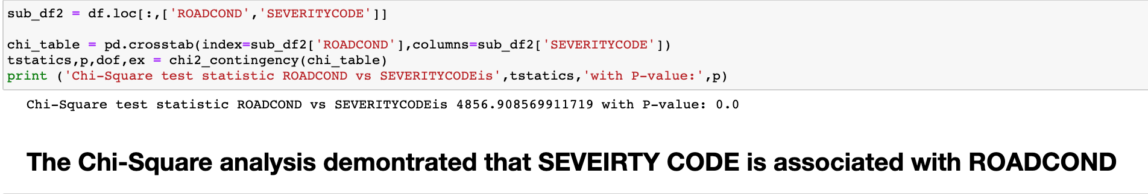

and Pearsons Correlation analysis for continuous features. E.g SDOTCOLNUM, with Pearsons output P-value, the NULL hypothesis was rejected and there is not linear relationship between SEVERITYCODE and SDOTCOLNUM. Thus, SDOTCOLNUM was removed from future analysis.

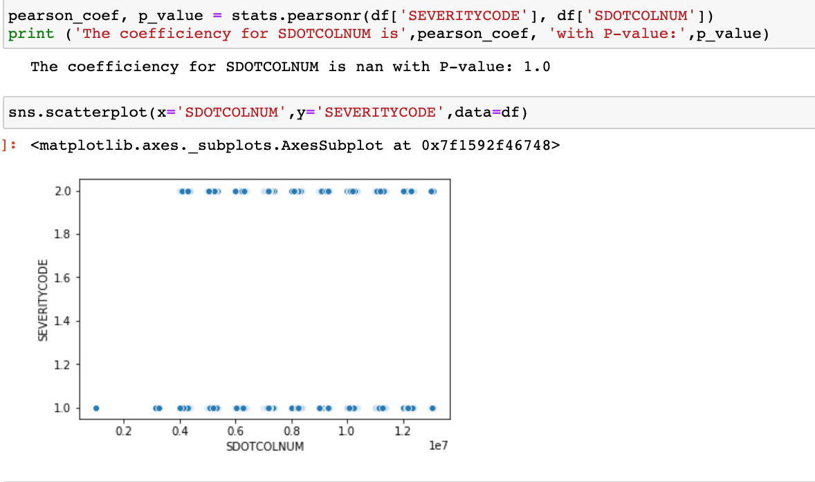

After that, except the necessary features dataset from the raw data. Since most machine learning algorithms require the number data as input. We will perform the encode the categorical features by using sklearn.proprocessing.LabelEncoder() method to encode the data.



Now, data set is ready for next step.

**Data Visualization:**

From the incidents data and its Longitude (X) and Latitude (Y) information, the Seattle Open Street map will indicate the most hot area with highest number of car accidents, which will alert drivers to be more careful in these areas. And according, the police station, hospitals could also arrange more manpower and facilities to fast respond to the accidents (for illustration purpose, only the first 1000 data points were plotted). From the map, we can observe the most car accidents happened along the mainroads.

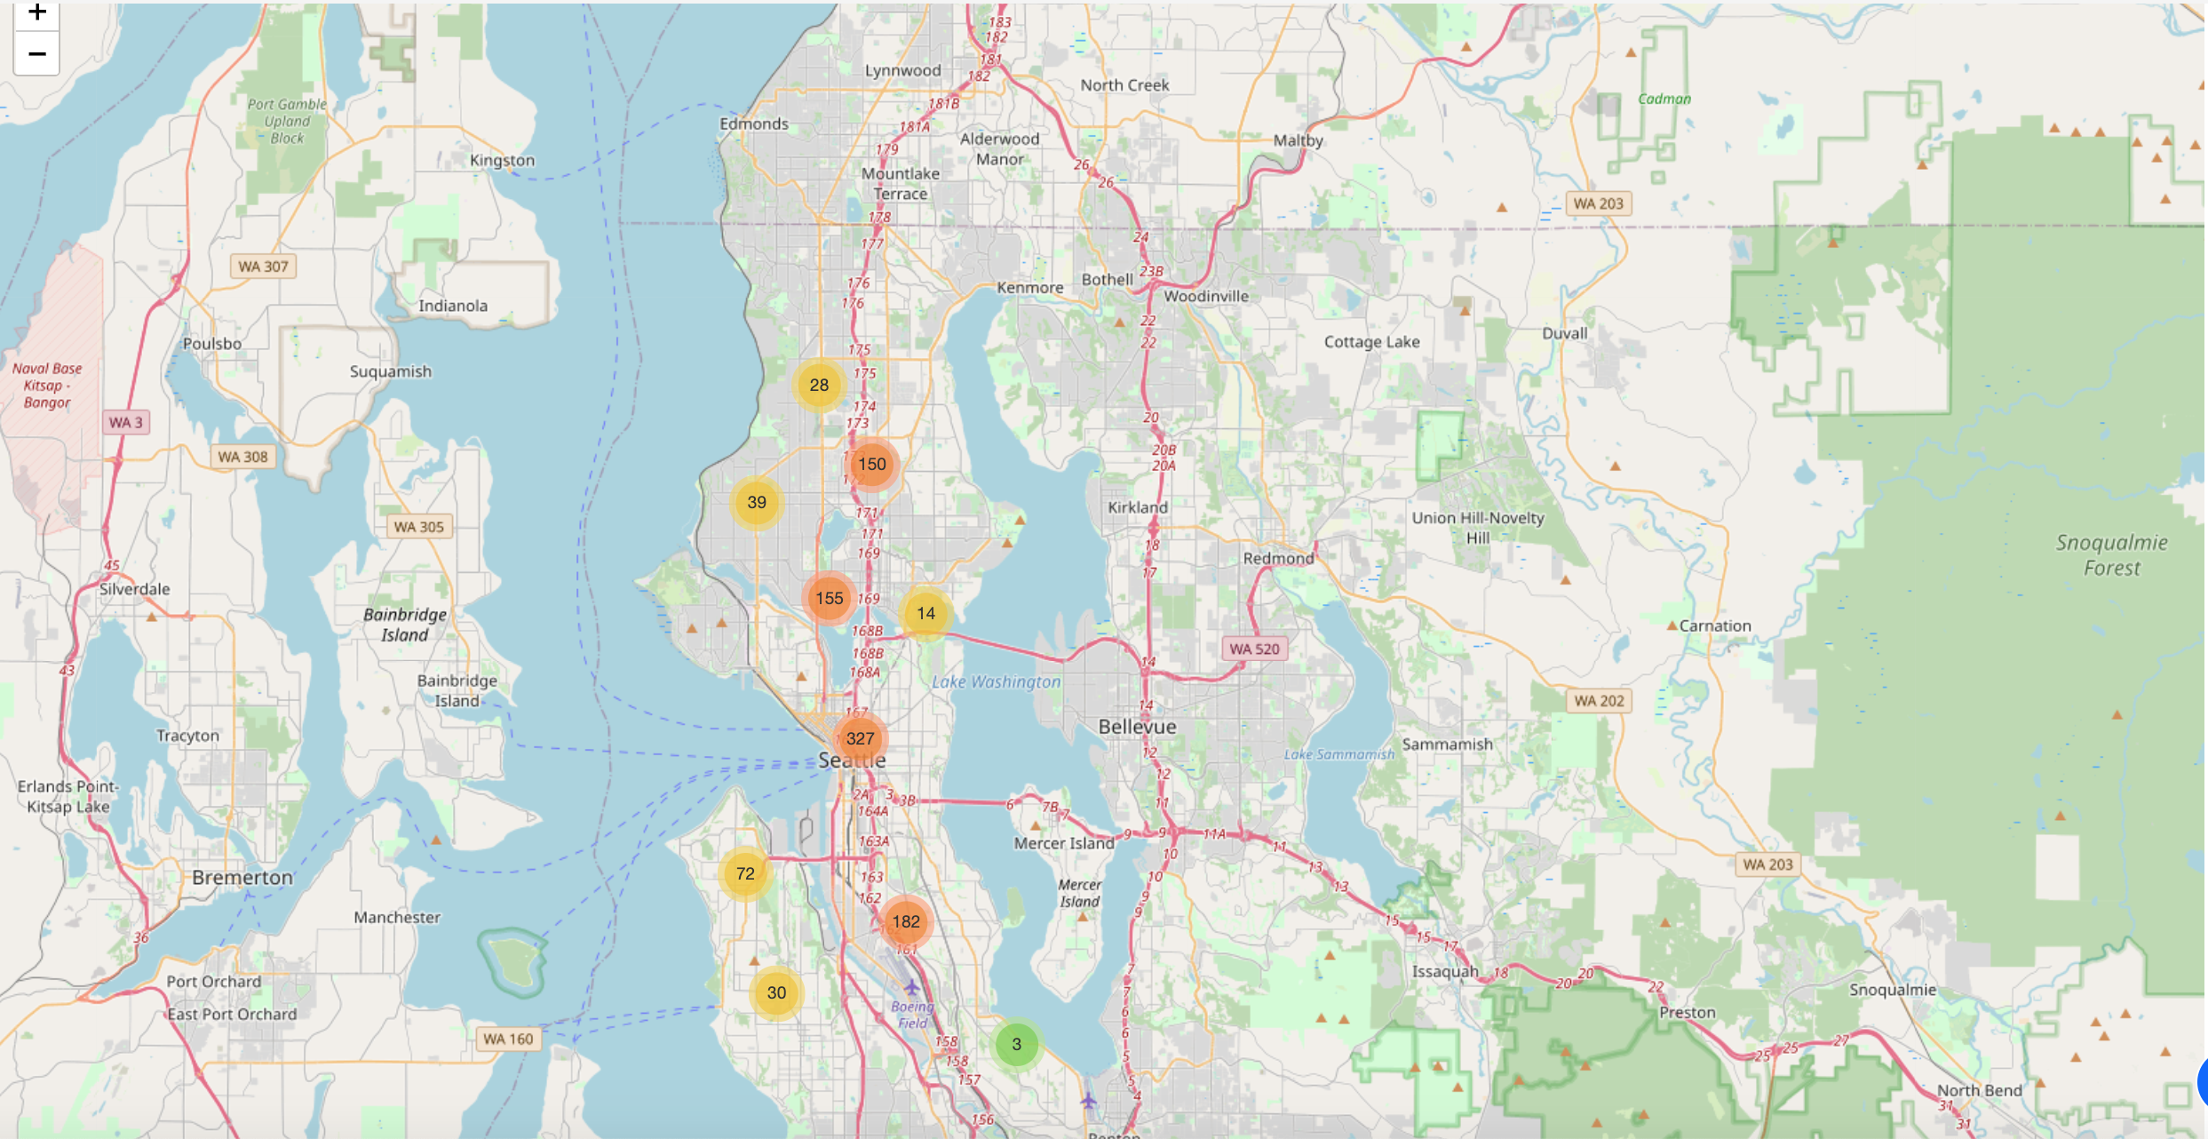

Further checking the relationship between Features: Day of week, Road Condition, Weather Condition, Light Condition and the number of car accidents. We can observe there are certain factors with significant number of car accidents associated.

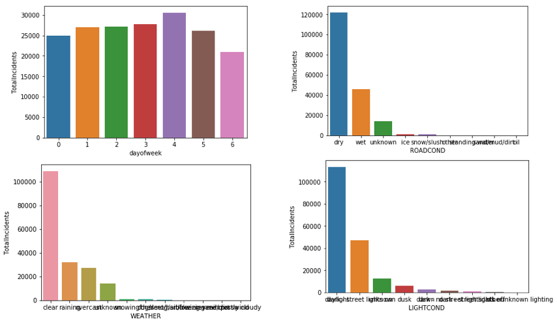

Similarly, we can also plot the bar chart of Road type and Junction Type, “Block” – ‘mid-block’, intersection occupy significant number of car accidents.

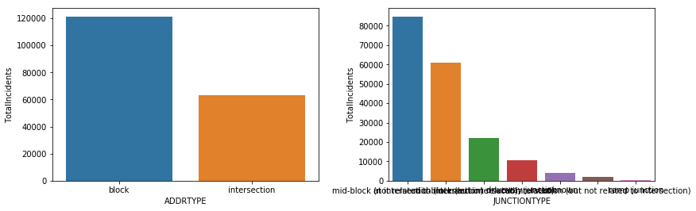

Statistic correlation can be observed here:

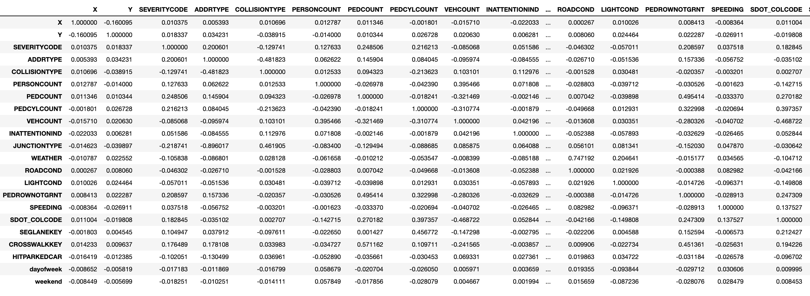

**Methodologies – Build & Evaluate the Model**

* **Train and Test data split**

Data will be split with 70% used for train data and 30% used for verifying the model purpose. Before doing that, data will be standardized.

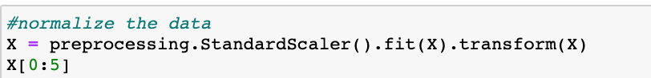

The final data set size is as the following:

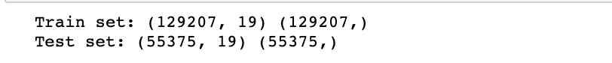

* **Build the model**

“LogisticRegression” and “DecisionTreeClassifier” are used to build the model

* **Evaluate the two model:**

The logistic regression model’s evaluation results:

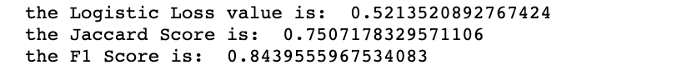

The Decision Tree model’s evaluation results:

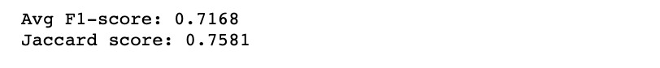

* **Results:**

By comparing the two models, logistic regression will be the better choice: with around 84% accuracy ratio, actually, it is not a bad model.

**Discussion:**

In this study, the relationship between Severity code and different attributes in the car accidents’ data were analyzed. And with statistic analysis (Chi-square and Pearsons), I have identified light conditions, road conditions, weather, inattention and junction types, day of week, weekend, pedrownotgrnt, collisiontype, sdot_colcode, hitparkcar are the significant subjective and objective factors associated with a car collision. Also built both regression models and classification models (decision tree) to predict the severity of car accidents. With the current trained data, Logistic regression model was selected. This model can be beneficial to SDOT, police, and drivers in several ways:

* + Help SDOT to take improvement actions, like:
    - installing more traffic signals on particular junction types in block and intersections, or
    - imposing speed limits in more collision causing areas, or
    - Build more sidewalk, or
    - More attention to pedestrians and parked cars, etc.
  + Help drivers be more alert while choosing roads, driving more carefully to avoid more collision causing junction types and plan the departure time with proper day of week.

**Conclusion**

We can conclude that, with current available data, the Logistic Regression is the best model in this scenario. An interesting point to note here is the data set doesn’t contain any severity code that are more than 2 (and since it is the predicted variable, we couldn’t compensate the it with ‘cooked’ data!). If there are, I would suspect the Logistic Regression model would not take this significant fit. This needs further study after more data is available.

GitHub link - <https://github.com/songttony/Coursera_Capstone/blob/master/IBM%20DataScience_Capstone.ipynb>